horizontal line

EE208:CONTROL ENGINEERING LAB 05

# Controller design on MATLAB platform using discrete root loci

## 

## Course Instructor : Dr. Sanjay Roy

## Date : 10th February 2022



## Group Number - 14

## 

## Raj Kumar Deb 2020eeb1025

## Tushar Sharma 2020eeb1325

## Tiya Jain 2020eeb1213

# 

# 

# 

# TABLE OF CONTENTS

1

**TABLE OF CONTENTS** **2**

**1. OBJECTIVE** **4**

**2. GIVEN** **4**

2.1 GIVEN BLOCK DIAGRAM 4

2.2 GIVEN INFORMATION OF OLTF 4

**3. THEORY** **5**

3.1 CLOSED LOOP TRANSFER FUNCTION BLOCK DIAGRAM 5

3.2 CLOSED LOOP TRANSFER FUNCTION 5

**4. OBSERVATIONS & THEIR ANALYSIS** **6**

4.1 ROOT LOCI ANALYSIS 7

4.2 IMPACT OF VARIATION IN FEEDBACK GAIN 8

4.2.1 Analysis of the proximity to instability as the CLTF is operated at different feedback gains settings 9

4.2.2 Impact on PHASE MARGIN with variation in Gain K 9

4.2.3 Impact on GAIN MARGIN with variation in Gain K 10

4.2.4 Impact on SYSTEM PARAMETERS with variation in gain K 13

4.3 IMPACT OF VARIATION IN SAMPLING TIME 14

4.3.1 ON PHASE MARGIN 14

4.3.2 ON GAIN MARGIN 14

4.3.3 ON SYSTEM PARAMETERS 15

4.4 SENSITIVITY ANALYSIS 17

4.5 Selection of final value of K 19

**5. CONCLUSION** **20**

**6. MATLAB SCRIPTS** **21**

# 

# 1. OBJECTIVE

* In this experiment, we are supposed to examine the consequences on gain and phase margins when the given OLTF is closed using negative feedback of various gains.
* Further, additional analysis of sensitivity with respect to the choice of sampling time is expected for the design procedure.

# 2. GIVEN

## 2.1 GIVEN BLOCK DIAGRAM

###### 

#### Figure 2.1.1 Block diagram for the OLTF of the given system

## 2.2 GIVEN INFORMATION OF OLTF

|  |
| --- |

#### Figure 2.2.1 Open Loop Transfer Function of the given system

# 

# 

# 3. THEORY

## 3.1 CLOSED LOOP TRANSFER FUNCTION BLOCK DIAGRAM

### 

#### Figure 3.1.1 Block diagram for the CLTF of the given system

## 3.2 CLOSED LOOP TRANSFER FUNCTION

The CLTF is written using the formula :

| = |
| --- |

#### 

#### Figure 3.2.1 Closed Loop Transfer Function of the given system

# 

# 

# 4. OBSERVATIONS & THEIR ANALYSIS

Our initial approach to the problem was to convert the digital system into its analog counterpart and then start analyzing the system. *BUT* using the siso tool on MATLAB we realized that there were anomalies observed w.r.t. bandwidths .We found that the analog bandwidths were greater than the digital ones. We weren’t able to explain this unusual phenomenon. Therefore we switched our approach.

Now remaining in the digital z domain, we tried to find suitable ranges of K for which our system ( inclusive of a first order actuator) is stable by using the root loci method in the Z-plane.

## 4.1 ROOT LOCI ANALYSIS

#### 

#### Figure 4.1.1 Root Loci Plot for the given CLTF

* The system parameters for K = 1.07 were observed to be: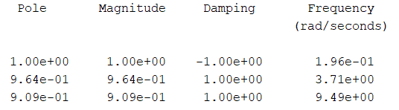

We observed and analyzed from the plot — the position of the roots, their locus and associated information.

**\*\*We conclude that for the desired closed loop system to be stable, the gain must lie approximately around 1.09 to 4.82.**

Thus, for positive integral values of gain K (as expected from the question), the values

**K = 2, 3 and 4** are suitable for ensuring stability.

## 4.2 IMPACT OF VARIATION IN FEEDBACK GAIN

### 4.2.1 Analysis of the proximity to instability as the CLTF is operated at different feedback gains settings

More stable systems are expected to have a significant gain margin and phase margin. As these margins shrink, so does the stability.

The characteristic equation of the CLTF is as follows:

For the stability analysis, gain margin and phase margin of GCL were calculated for different values of K, using a bode plot (MATLAB). The graphs and their interpretations are as follows:

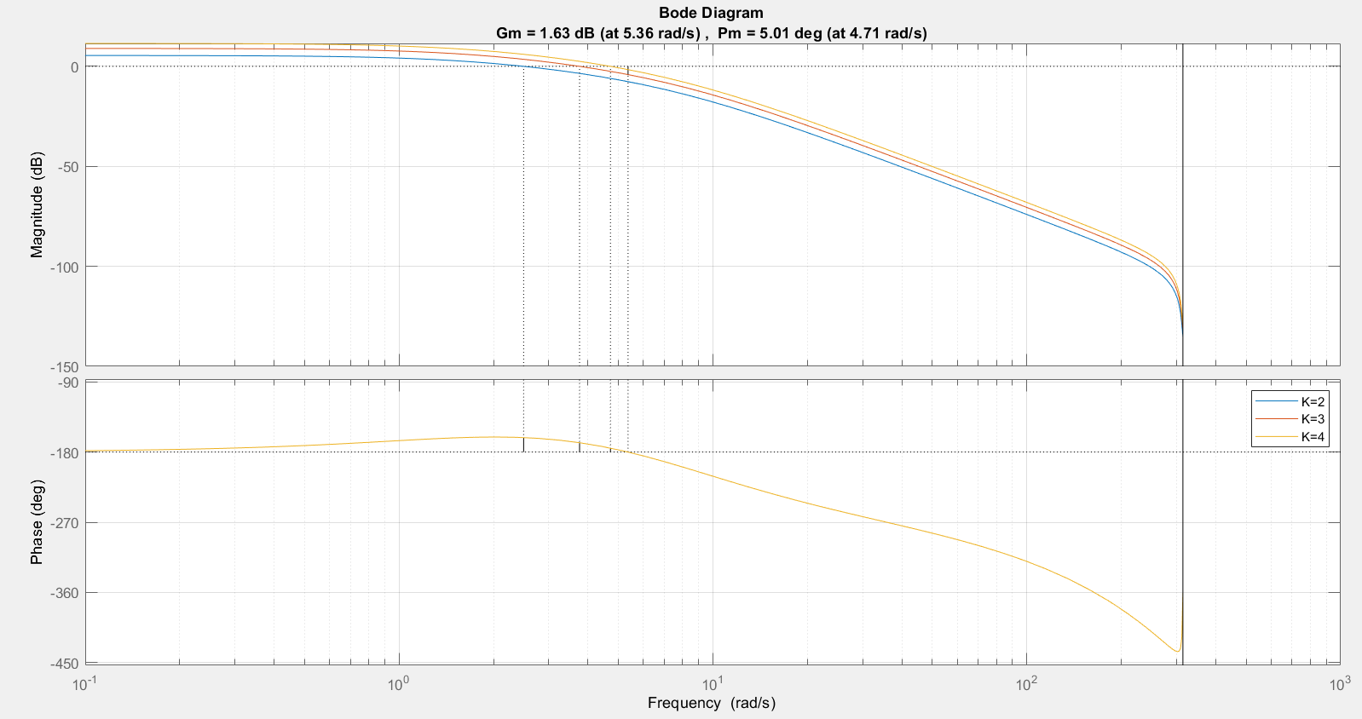

#### Figure 4.2.1.1 Bode Diagram for the K*

We plot the bode diagrams for our desired gain values (). Matching the gain cross frequencies we obtain the following data:

| **K** | **GM** | **PM** |  |  |
| --- | --- | --- | --- | --- |
| 2 | -5.44 dB | 18.6ᐤ | 0.00 rad/s | 2.49 rad/s |
| 3 | 4.12 dB | 12.0ᐤ | 5.36 rad/s | 3.76 rad/s |
| 4 | 1.63 dB | 5.01ᐤ | 5.36 rad/s | 4.71 rad/s |

### As we know, the system becomes unstable if the gain crossover (GCO) frequency and the phase crossover frequency (PCO) are equal. For a practical system, it is expected that the system has the difference between its GCO frequency and PCO frequency as large as possible in order to avoid any chances of being unstable in case it gets disturbed.

### In the above table for example, at K = 2 the difference is about 2.49 rad/s, at K =3 the difference is about 1.6 rad/s and at K = 4, the difference is about 0.65 rad/s. So, the proximity to instability is least for K =2, more for K =3 and most for K =4.

### 4.2.2 Impact on PHASE MARGIN with variation in Gain K

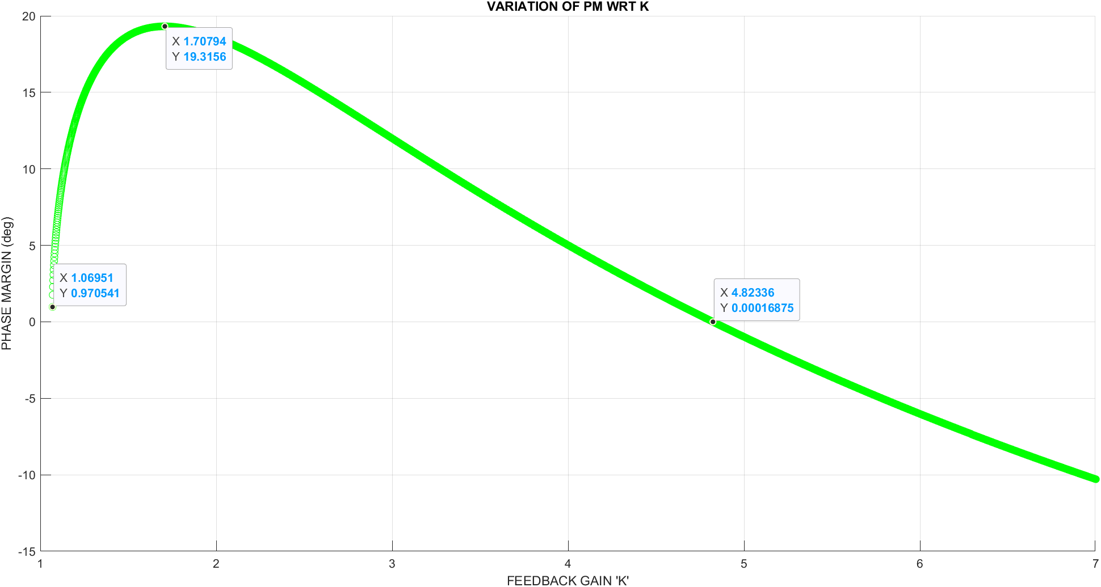

#### Figure 4.2.2.1 Phase Margin vs Feedback Gain

* For K < 1.0695 (approx), the value of phase margin was obtained to be *infinite* (hence not visible in the above plot).
* We can further notice from the above graph that for values of K approximately between 1.07 and 1.71, the graph is increasing and after that it starts decreasing. The peak of phase margin occurs at which is 19.31°. We also observe the transition point where the phase margin becomes zero which is near the point where .

### 

### 

### 4.2.3 Impact on GAIN MARGIN with variation in Gain K

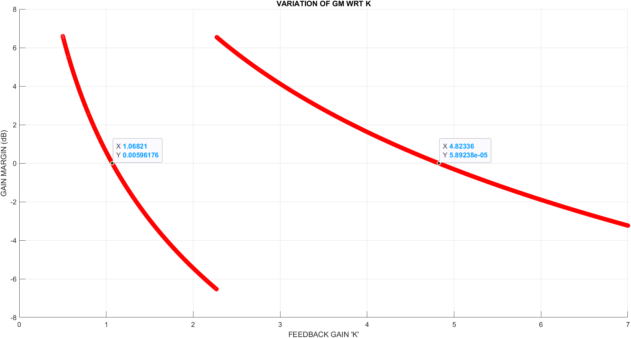

#### Figure 4.2.3.1 Gain Margin vs Feedback Gain

* We observe that the graph first intersects the 0 gain margin line when Feedback Gain = 1.06821and then again at Feedback gain = 4.82336. The system starts getting stable from K=1.06821
* From the above graph we can say that there is discontinuity in the graph near the point where . The gain margin first decreases then there is abrupt change from negative (-6.54dB) to positive (6.54 dB).
* After that the gain margin decreases almost linearly and after we observe that the gain margin values become negative.
* At the point of K = 2.2706731, where we see that there is discontinuity. The step response at this point was still identical to those at the nearby points.

### 

### 4.2.4 Impact on SYSTEM PARAMETERS with variation in gain K

We observe the step responses for the various values of K to know the nature of our discrete system.

* **Feedback Gain *K = 1***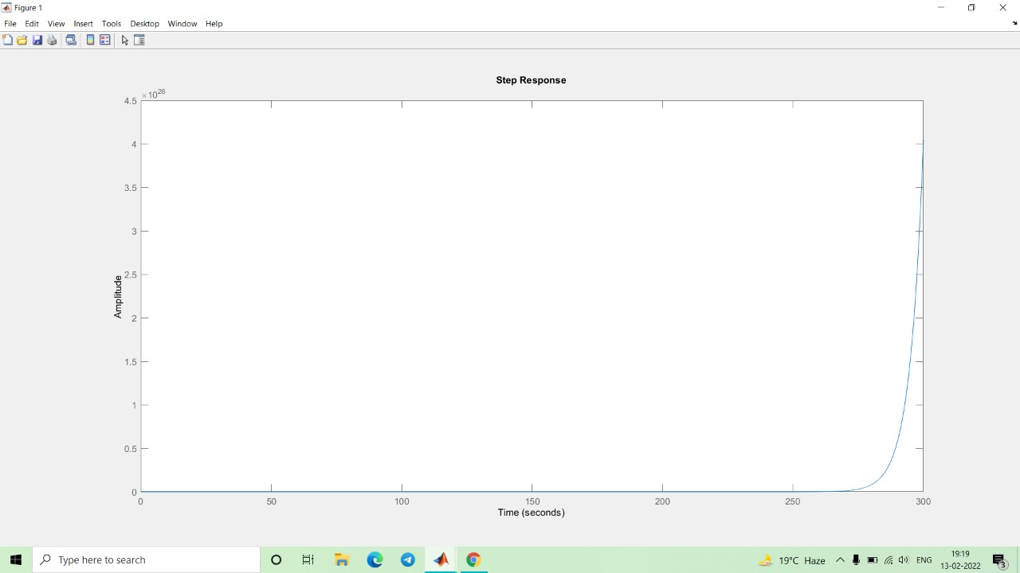

#### Figure 4.2.4.1 Step Response for K=1

The step response for the system becomes unbounded when and hence is undesired, as was already expected from our previous analysis.

* **Feedback Gain K = {2,3,4}**

| **K=2** | **K=3** | **K=4** |
| --- | --- | --- |

#### Figure 4.2.4.2 Step Response for K = {2,3,4}

The step responses are stable for the cases where K = 2,3 or 4, as we have deduced the overall CLTF to be stable for these integer values.

* **Feedback Gain K= 5**

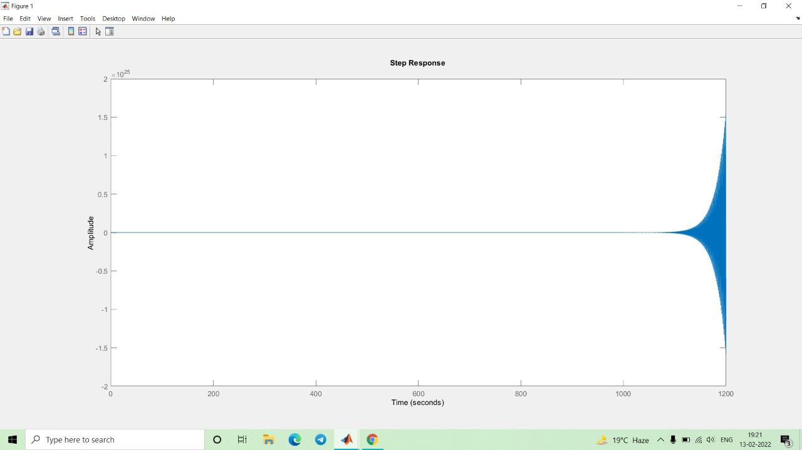

#### Figure 4.2.4.3 Step Response for K = 5

Now as we move further with the values for our Feedback Gain , we obtain an unstable step response which goes unbounded as time increases.

For the stability of the given OLTF, we take integral feedback gain values from 1.07 to 4.82. The general trends observed are :

| **LOWER VALUES OF K** | **MEDIUM VALUES OF K** | **HIGHER VALUES OF K** |
| --- | --- | --- |
| Settling time, rise time & peak time are higher, whereas overshoot is lower. | Settling time, rise time, peak time and overshoot are normal. | Settling time, rise time, peak time are lower, whereas overshoot is higher. |
| The peak doesn’t come down again. **It shows** **Non oscillatory behavior.** | The peak came down again. It **shows** **Oscillatory behavior.** | The peak came down again. **It shows Oscillatory behavior.** |

## 

## 

## 

## 

## 4.3 IMPACT OF VARIATION IN SAMPLING TIME

### 4.3.1 ON PHASE MARGIN

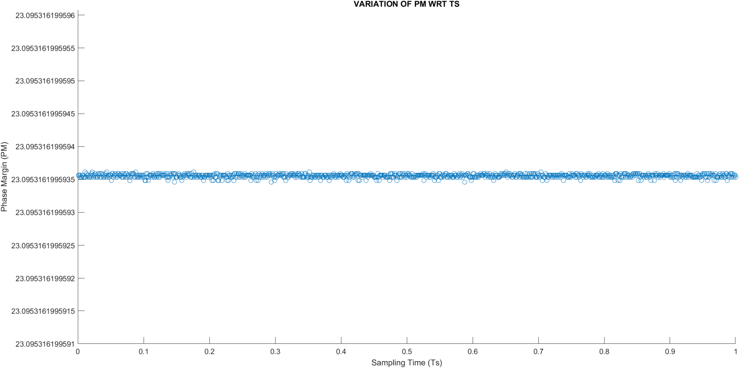

#### Figure 4.3.1.1 Phase Margin vs Sampling Time

We see that the phase margin doesn’t change significantly on varying the sampling time. A very slight disturbance was observed on increasing the precision which is expected due to minor computational errors of MATLAB. This can be also confirmed from the fact that in the z domain, . The zeros and poles are constant in the z-domain. Which means that if the sampling time is decreased by a factor ‘𝛕’ then **⍵GCO & ⍵GCO** should increase by the same factor. This is the reason we obtain a constant Phase Margin even on changing the sampling time.

### 4.3.2 ON GAIN MARGIN

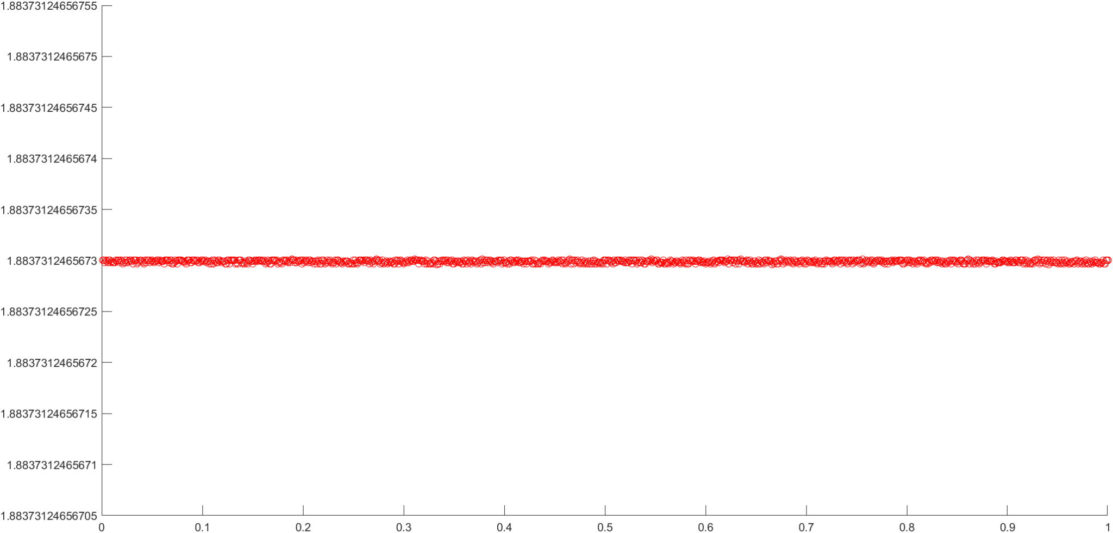

***Figure 4.3.2.1 Gain Margin vs Sampling Time***

We see that the gain margin doesn’t change significantly on varying the sampling time. A very slight disturbance was observed on increasing the precision which is expected due to minor computational errors of MATLAB. This can be also confirmed from the fact that in the z domain, . The zeros and poles are constant in the z-domain. Which means that if the sampling time is decreased by a factor ‘𝛕’ then **⍵GCO & ⍵GCO** should increase by the same factor. This is the reason we obtain a constant Gain Margin even changing the sampling time.

### 

### **4.**3**.3 ON** SYSTEM PARAMETERS

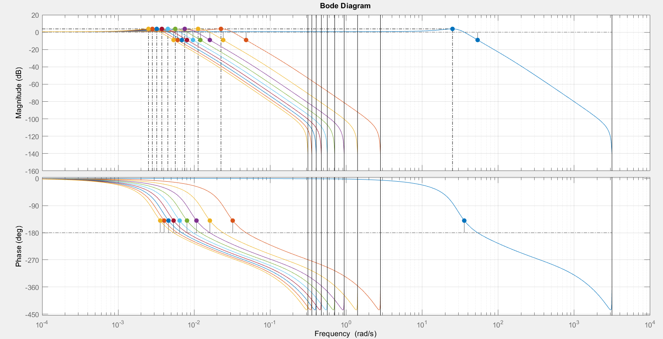

#### Figure 4.3.3.1 Bode Plot for different Sampling Time

In the above bode plot we can see the shift of graph towards left as the sampling time increases. This follows that as sampling time changes the frequency will also change accordingly, to make the zeros and poles constant. This is the reason for the shift as the frequency is decreasing for the points.

|  |  |
| --- | --- |
|  |  |

On observing the system parameters of the given transfer function, we find that the timed parameters change w.r.t. to the Sampling Time, whereas the overshoot value changes only w.r.t Feedback Gain.

The *Feedback Gain* maintains a *direct relationship* with settling time and overshoot, whereas *indirect relationship* with rise time and peak time. *Sampling time* maintains a direct relationship with rise time, peak time, settling time and that too a **linear** one as shown in the later section.

## 

## 

## 4.4 SENSITIVITY ANALYSIS

In order to showcase the concept of sensitivity we find the differential form of sensitivity w.r.t. **Gain K** and through observing the gain and phase margins for given values of K w.r.t. **Sampling time T.**

* **wrt Gain K ()**

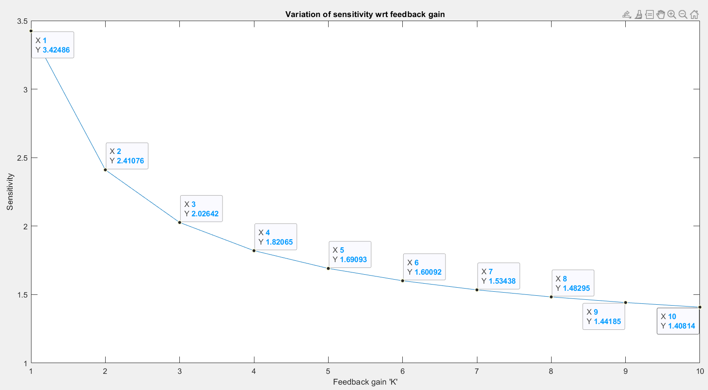

#### Figure 4.4.1 The sensitivity curve wrt K

We used MATLAB to find the sensitivity of our transfer function wrt various values of K. We found out that the graph was very uniform and the sensitivity was found to be decreasing with the increase in feedback gain K.

Hence, we can say that the sensitivity of the transfer function reduces as we move ahead with larger values of K.

* **wrt to sampling time (T)**

| Figure 4.4.2 Settling time VS Sampling Time | Figure 4.4.3 Overshoot VS Sampling Time |
| --- | --- |

* We observe from the above graph that the Settling Time (similarly for Rise Time, Peak Time) linearly increases w.r.t sampling time . Thus changing the sampling time affects the settling time, in other words we can say that the time parameters of the transfer function are sensitive to sampling time, whereas overshoot is constant.
* We also found that the Gain and Phase margins didn’t change w.r.t change in sampling time. A slight disturbance was observed as we increased the interval of precision of gain and phase margins (Though the variation is almost negligible it might be computational).

## 4.5 Selection of final value of K

We can see a ***tradeoff*** between the *settling time* and *peak time* w.r.t Feedback Gain. We also observed a ***tradeoff*** earlier that we can obtain a *lower overshoot* when using lower gain & *lower settling time* using higher gain value. Therefore while comparing the values of them at K = {2,3,4}

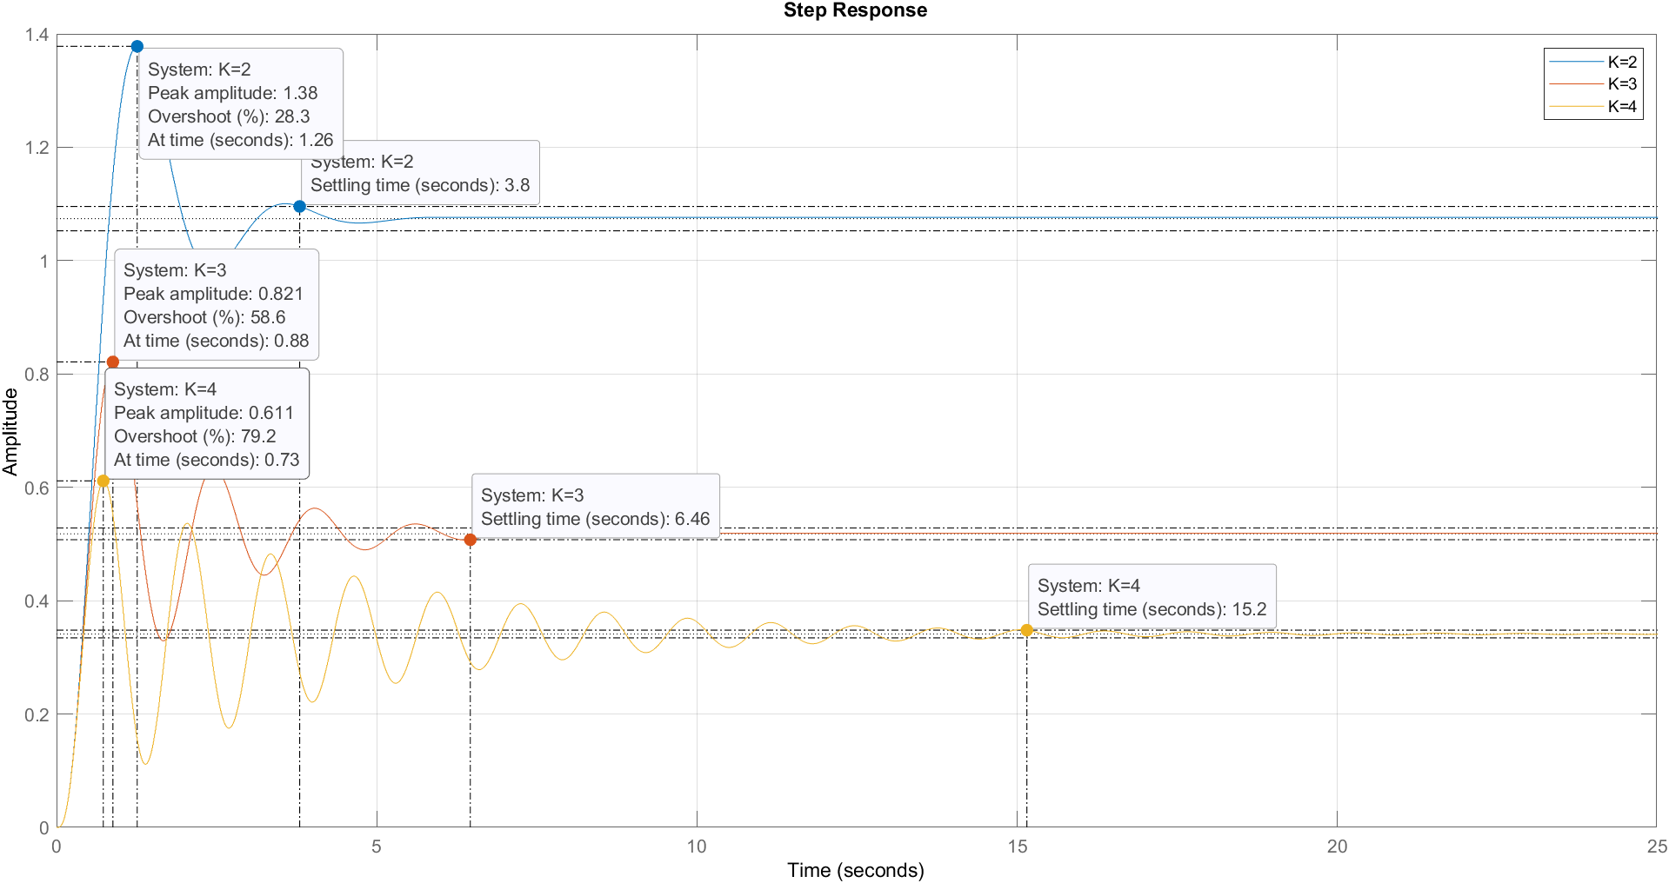

We realize that the oscillations increase as K increases, and for K = 1 the step response stays unstable. The settling time is larger for K = 4 and comparable for K = 2 & 3. The gain margin is negative for K = 2 and sensitivity is also quite high for K = 2.

***So, we decided to take the Feedback Gain value ‘3’ for our furnace model system.***

## 

# 

# 5. CONCLUSION

* Root Loci Analysis was done for the system and was found to be stable for the values of K in range **approximately around *1.09 to 4.82*.**
* Further, step responses were found for *K =1, 2, 3, 4 and 5*, to cross check our analysis and the responses were found to be stable for K = 2, 3, 4 and unstable for *K = 1, 5* just as we expected.
* The impact on the gain and phase margins were observed on varying the values of Feedback gain and Sampling Time independently.

| **Change?** | **GM** | **PM** | **Overshoot** | **Settling Time** | **Rise Time** | **Peak Time** |
| --- | --- | --- | --- | --- | --- | --- |
| **Feedback Gain** | First , then with a jump, then | First then peak, then |  |  |  |  |
| **Sampling Time** | NO | NO | NO |  |  |  |

* Sensitivity analysis was then performed with respect to the variation in gain K (through differential form) as well as in sampling time (through analysis of gain and phase margins).
* We finally take the value of Feedback Gain = ‘3’, which has positive Gain & Phase margins and oscillatory behavior of step response with lower settling time.

=

# 6. MATLAB SCRIPTS

